***Calculator−assumed Solutions***

11. (a) The number of phones she is given to repair for the week. ✓

(b) She fixes 23 per day, for 4 days 23 x 4 = 92 phones ✓

(c) 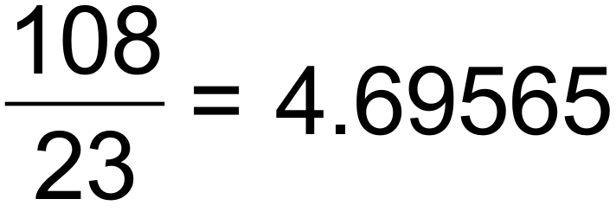 days ✓

 hours

5 hours and 34 minutes ✓

(d) T1 =155 T2 = 128 T3 = 99 T4 =68

Tn+1 = Tn – (25 +2n) T0 = 180 ✓✓ [6]

12. (a) 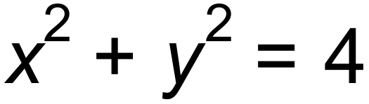 ✓

(b)  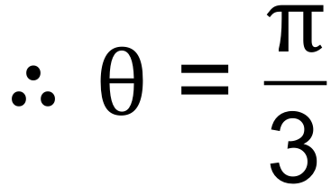 radians ✓

radius = 2 units ✓

(c) 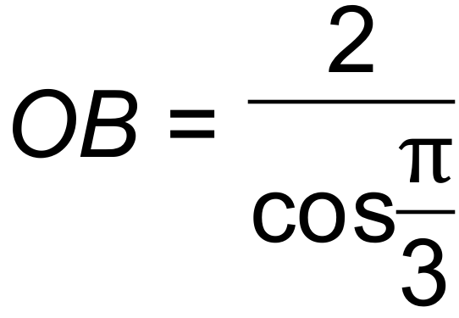 = 4

Therefore area of ΔAOB = 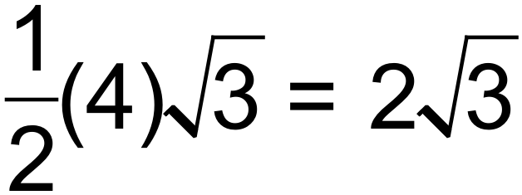 units2 ✓

Area of sector = 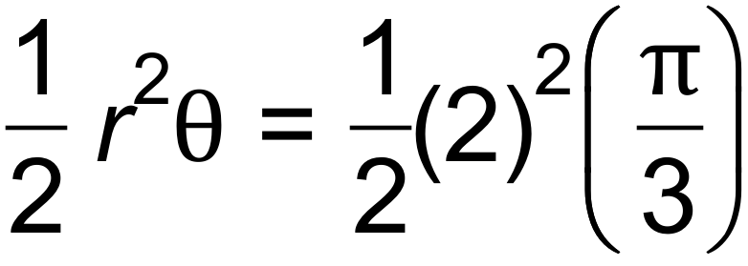

= 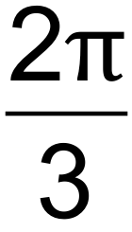 units2 ✓

Area of shaded part = triangle – sector

= 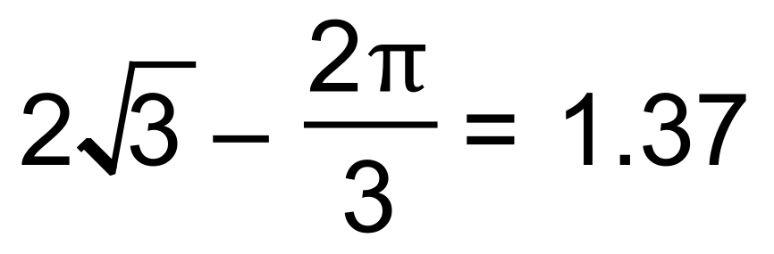units2 (3 sig fig) ✓ [6]

13. (a) 5.1 seconds ✓

(b) 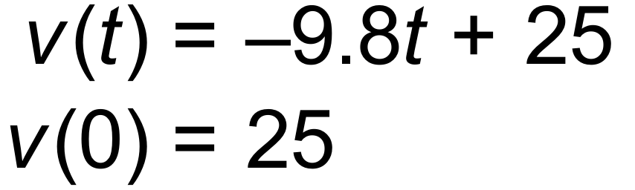 ✓✓

(c) Maximum height is 31.89 m when 

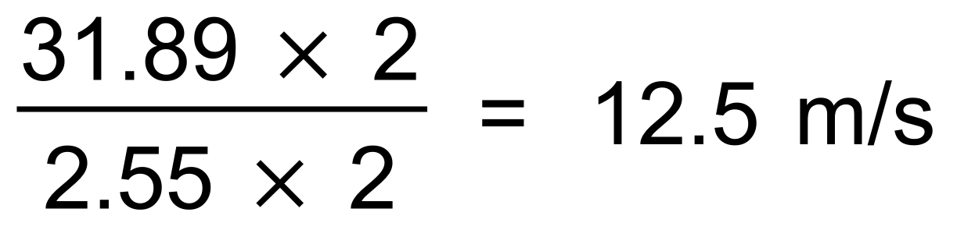 ✓✓ [5]

14. (a) 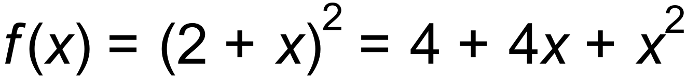 ✓

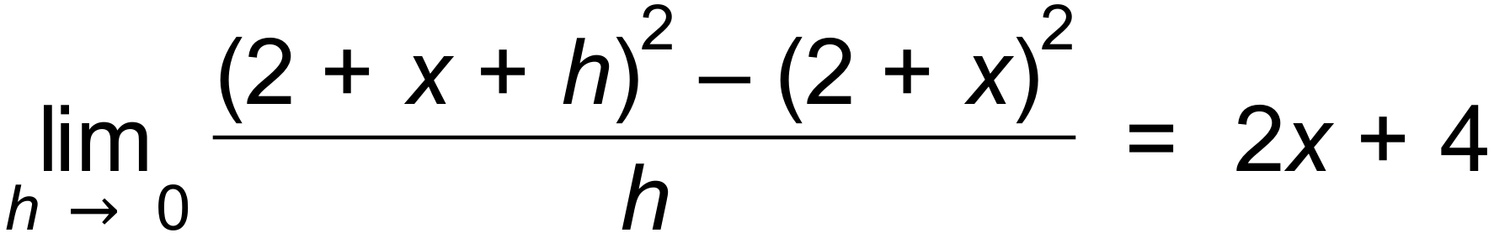 ✓

(b) (i) 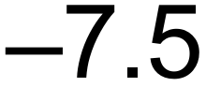 ✓

(ii) 18 ✓

(c) 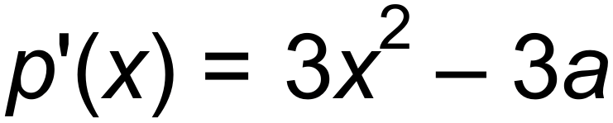 ✓

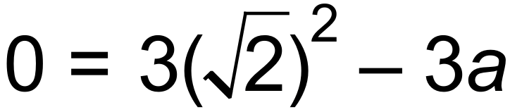

 ✓

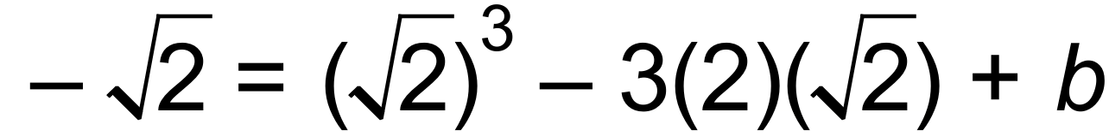

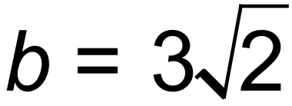 ✓ [7]

15. (a) 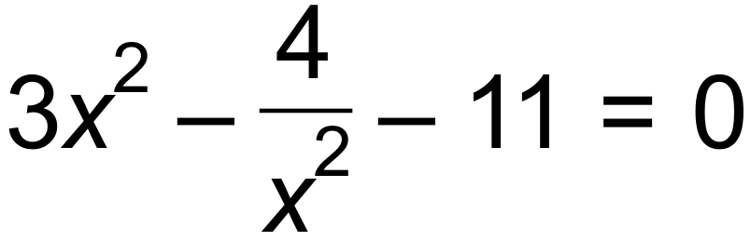

 ✓✓

|  |  |  |  |  |  |
| --- | --- | --- | --- | --- | --- |
|  |  |  |  | 2 |  |
|  | + | 0 |  | 0 | + |
| y | ↑ | - | ↓ | - | ↑ |

(b)

✓✓

 Maximum

 Minimum ✓

(c) 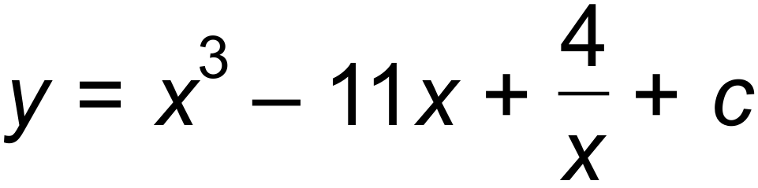 ✓



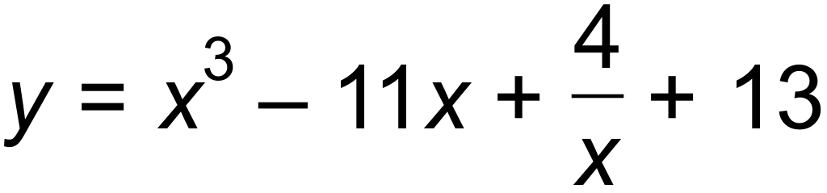 ✓

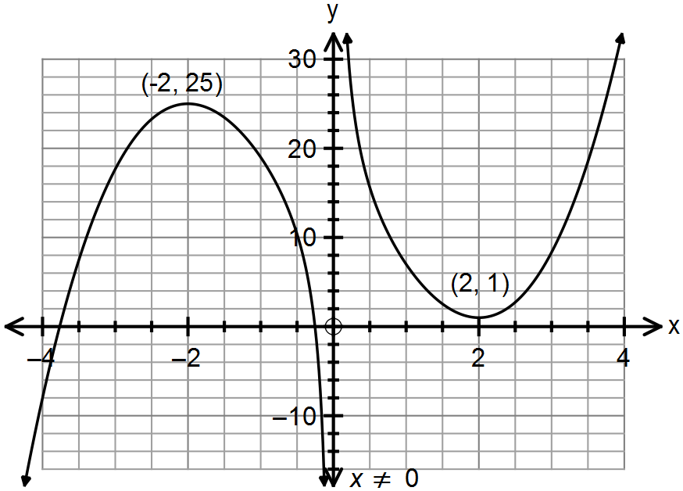(d)

✓✓✓ [10]

16. (a) (i) T100 = 23 +(99)(9) ✓

= 914 ✓

(ii) 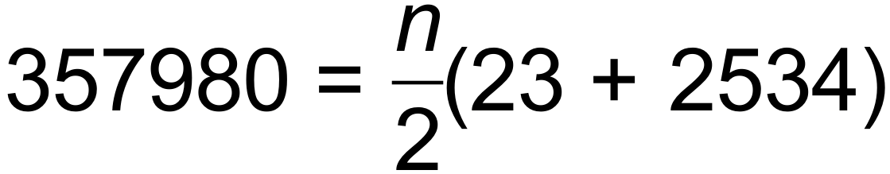 ✓

 ✓

(b) (i) Tn+1 = Tn T1 = 12 ✓✓

(ii) 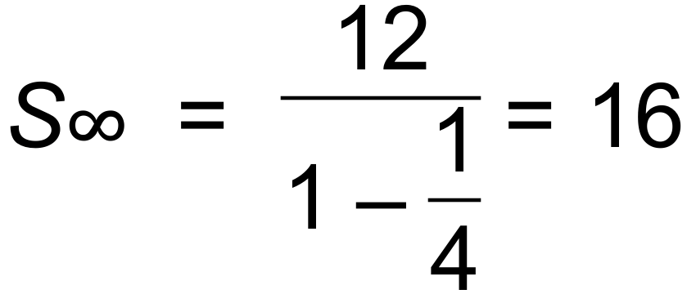 ✓✓ [8]

17. (a) 92°C (initial temp of tea) ✓

22°C (room temp) ✓

(b) After 4.12 mins and before 7.45 mins ✓✓



(c) Horizontal asymptote 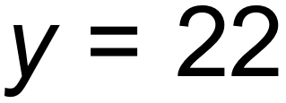 ✓

The tea will cool at a decreasing rate as it approaches room

temperature which is 22°. ✓ [6]

18. (a) 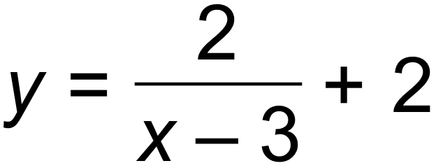 ✓✓

(b) 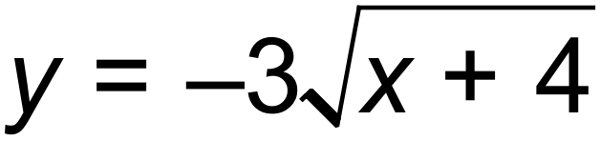 ✓✓

(c) 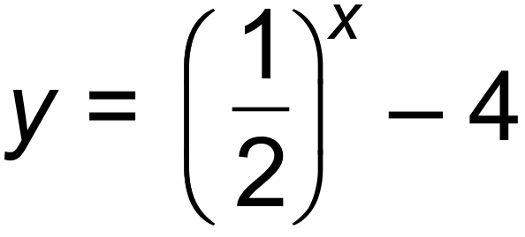 ✓✓ [6]

19. (a) 0.2 ✓

(b) 0.5 ✓

(c) 0.3 ✓

(d) Pr(X  Y) = Pr(X) x Pr(Y) if independent

Pr(X  Y) = Pr(X) + P(Y) - Pr(X  Y) ✓

Pr(X) + Pr(Y) - Pr(X  Y) = Pr(X) x Pr(Y) ✓

Let Pr(Y) = k

0.5+ k - 0.8 = 0.5k

k = 0.6 = Pr (Y) ✓ [6]

20. (a) 1, 3, 7, 15,…

Tn+1 = Tn + 2n T1 = 1 ✓✓

(b) 20 sets ✓ [3]

21. (a) (i) 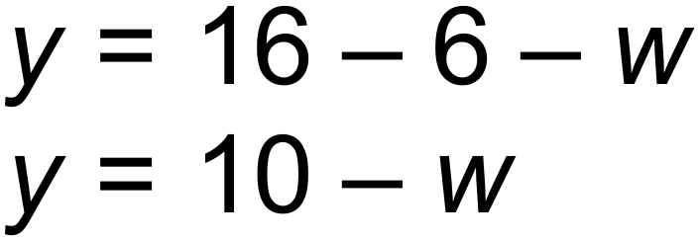 ✓

(ii) 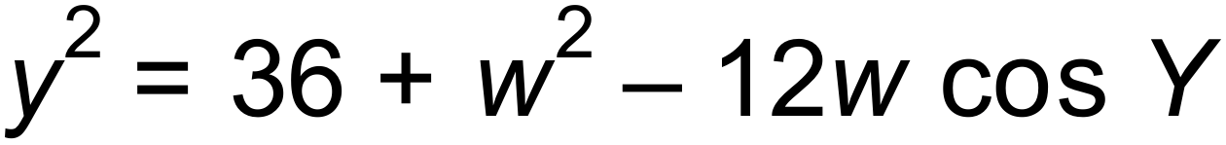 ✓

(iii)  ✓

 ✓

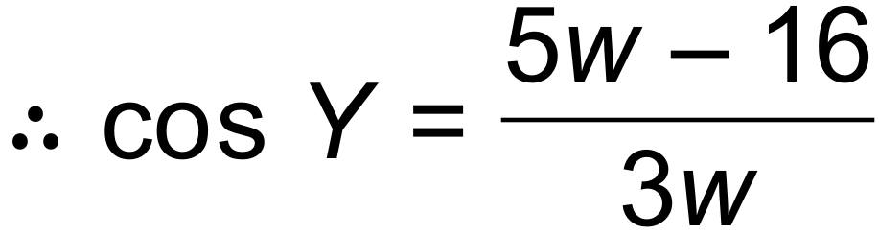

(b) (i) 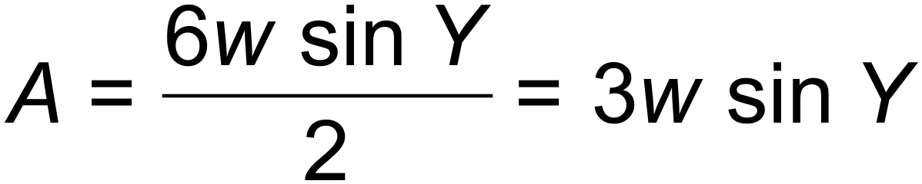 ✓

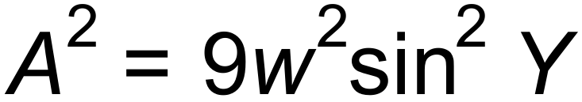 ✓

(ii) 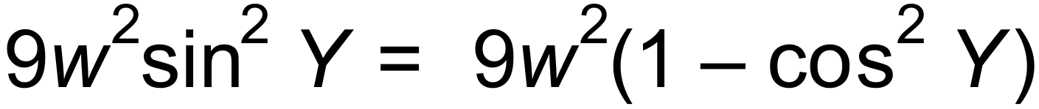 ✓

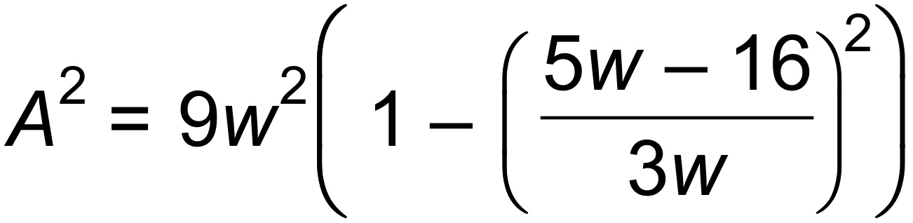 ✓

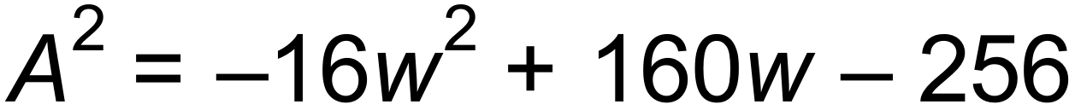 ✓

(c) (i) 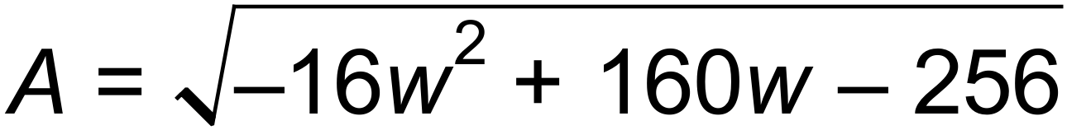

 ✓

Maximum area = 12 units2 ✓

(ii) 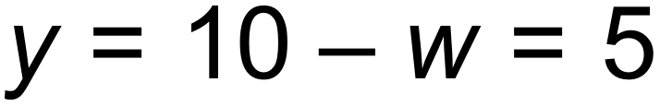

The triangle is isosceles. ✓ [12]

22. 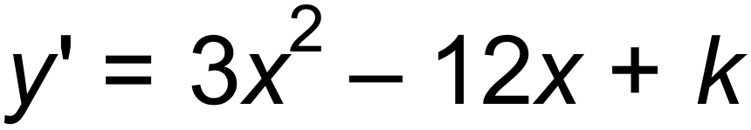 ✓

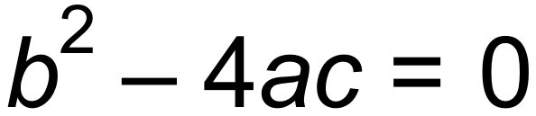 for one solution

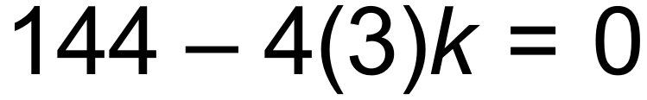 ✓

 ✓ [3]

23. (a) W = W0 (1.085)t

R = R0 (0.95)t

10W0 = R0

W0 (1.085)t = 10 x W0 (0.95)t ✓

(1.085)t = 10(0.95)t

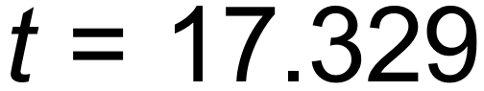 years ✓

After 18 years there will be more wallabies. ✓

(b) Wn+1 = 1.085 Wn W0 = 655 ✓

W5 = 985 ✓ [5]

24. (a) 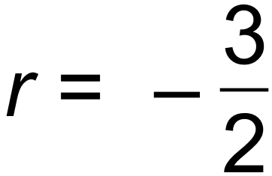 ✓

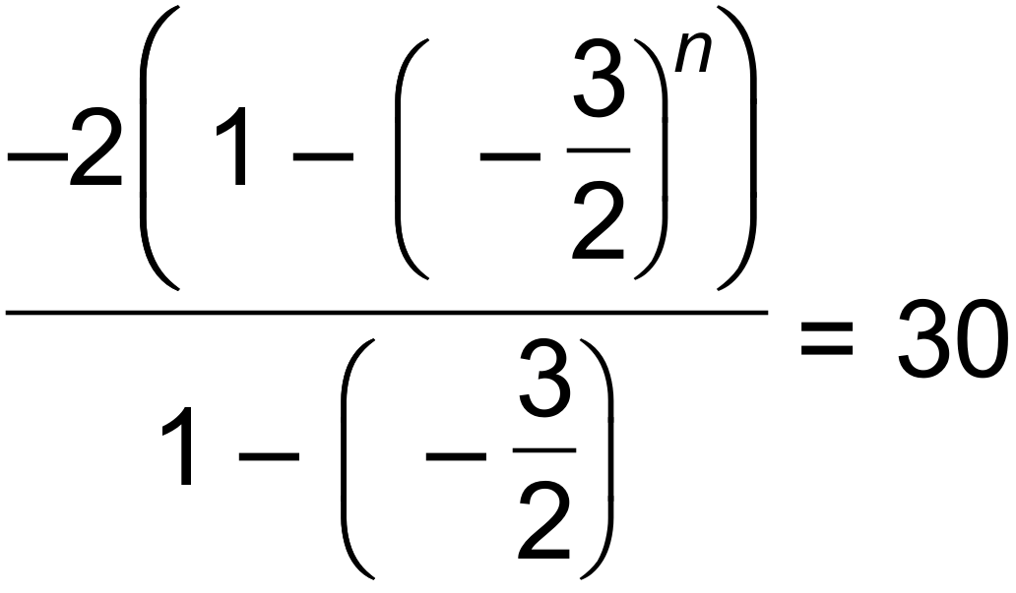  ✓



 ✓

(b) T5 = 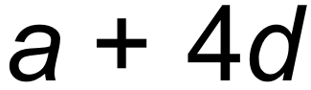 and T7 = 

 (eq 1) ✓

S15 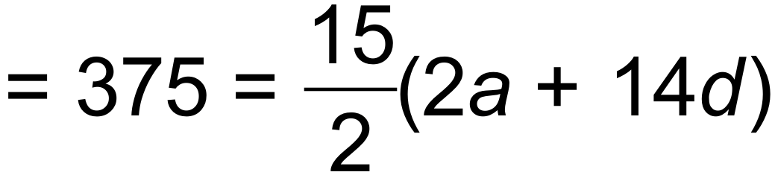 (eq 2) ✓

 ✓

S30 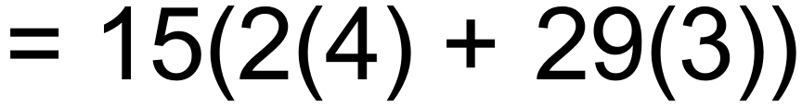 = 1425

Sum of next 15 terms = S30  S15 = 1050 ✓ [7]

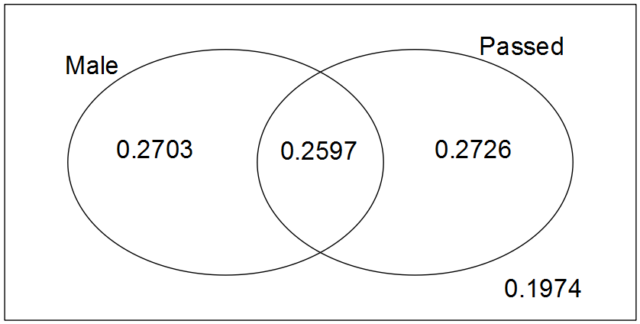25. (a)

✓✓✓

(b) (i) 0.5323 ✓

(ii) 0.2726 ✓

(iii) 0.51 ✓

(iv) 0.8026 ✓ [7]

26. The particle’s initial displacement is 5 m to the right of the origin. ✓

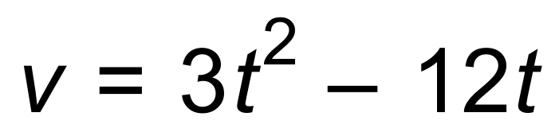 ∴ Initial velocity = 0 ✓ [2]